Forever the Sickest Kids
Media Bio

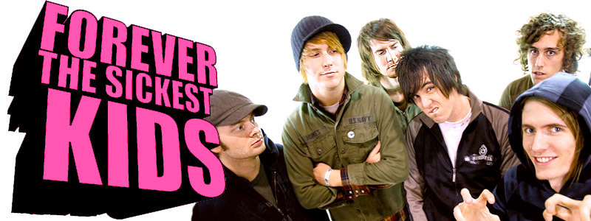
Success in the music business requires a magical combination of talent, perseverance and opportunity. The six young rockers in Dallas, Texas band Forever the Sickest Kids easily possess all this and more. They’re unquestionably gifted, ambitious and hard working, and in the eight months since they formed, they’ve repeatedly created their own opportunities – sometimes accidentally.

Five days after their official formation, singer Jonathan Cook was flipping through the Pure Volume web site when, with a click of his mouse, he inadvertently spent $350 the band didn’t have on a front page song placement. Worse still, Forever the Sickest Kids didn’t have any songs written yet. So, over the next two days, the band members got together and banged out a track called “Hey Brittany,” then recorded it with their friend/producer Jeff Rockwell. “Buying that Pure Volume spot was an amazingly great mistake,” laughs guitarist Caleb Turman, noting how “Hey Brittney” quickly becoming the band’s first big break. “The song just took off and after that everyone was suddenly interested in us.”

It’s easy to see why. “Hey Brittany” is a confectionary gem that combines elements of power pop, pop-punk, electro-pop and ‘80s radio rock into an unforgettable sing-along that resonates with the energy and vitality of youth. Contrary to popular belief, “Brittany” isn’t Britney Spears, but rather a girl who was engaged to be married, yet made no attempt to hide her affection for the members of the Forever the Sickest Kids. Since it was first posted, “Hey Brittany” has garnered over 2.5 million Internet plays and triggered a bidding war between eight major labels. Motown emerged victorious, and recently released the band’s EP Television Off, Party On, which features five fizzy, electric songs that should whet listener’s appetites until the band’s full-length debut comes out in XXX.

Like “Hey Brittany” Forever The Sickest Kids’ other songs tap into a place where boundless exuberance meets romantic disillusionment, and while the music is hardly a downer, it echoes with some bittersweet life lessons. “Believe Me I’m Lying,” starts acoustic and builds with syncopated electronic beats, then busts into an exuberant, guitar-blaring pop song with yearning lyrics (“Go ahead and cry yourself to sleep and think how you hate me so bad). The sugar rush of “She’s a Lady” is even more biting, as Cook sings, “I’m in love with a critic and a skeptic/ a traitor, I’d trade her in a second” over a bed of fist-in-air guitars and slithery synth lines.

“Our songs are about real stuff that’s happened to us because that’s what kids want to hear about,” guitarist Marc Stewart says. “They want to listen to stories about things that could happen to them as well, or that already have happened to them.”

While some of those stories, like “She’s a Lady” and “Becky Starz” are about girls that have hurt the guys’ feelings, Forever the Sickest Kids aren’t entirely innocent of emotional button pushing. “Believe Me, I’m Lying,” for example is about an occasion when Turman was caught red handed, leaving his girlfriend in tears.

“I was hanging out with some other girls, but I told my girlfriend that I was going out by myself,” he explains. “So, the girls and I decided to get some coffee, and as we’re walking to the car, my girlfriend pulled up and her headlights were right there in my face. I was totally busted.”

Although Forever the Sickest Kids have been around less than a year, their roots date back to the members’ childhood. Guitarist Marc Stewart and drummer Kyle Burns are stepbrothers and shared many musical discoveries in their early lives. Around the same time, guitarist Caleb Turman and bassist Austin Bellows became friends and started writing songs. Years later, Stewart met keyboardist Kent Garrison in high school. Then, when Garrison went to college, he hooked up with singer Jonathan Cook and Bellows. For a while, Turman and Bellows played together in the Dallas band Ben Bradley and everyone else from Forever the Sickest Kids rocked with The Flipside. But in late 2006, both of those groups reached a creative standstill, and the Sickest Kids were born.

“We all had the same idea and vision of where we wanted to go and how important the music was to us,” says Stewart. “This was something that we all really wanted.”

Immediately after writing “Hey Brittney,” Forever the Sickest Kids continued working on other ideas, and by the end of their first week, they had finished three songs. “The chemistry that we have together is awesome,” Turman says. “Whenever we get in a room together with our instruments, ideas just start pouring out.”

Within four month, the band had recorded Television Off, Party On and written many of the songs for their full-length debut. Then, Forever the Sickest Kids started playing shows, including a three-week stint on the indie stage of the Warped Tour. “That was the hardest thing we’ve ever done because a lot of people didn’t know who we were and we were constantly having to prove ourselves,” Stewart says. “But it was also the most rewarding thing because we were playing to over 1,000 people a day.”

As rigorous as Warped was, it paid off. Before Warped, Forever the Sickest Kids averaged 10,000 to 12,000 daily plays on their MySpace page. When they got home, the number jumped from between 15,000 and 22,000. And the band’s fanbase continues to grow.

“There’s a lot of word of mouth and the songs wound up on other people’s profiles, which really helps spread the word,” Turman explains. “The Internet has been an amazing tool for us, but there’s still nothing like playing in front of a live audience.”

So, just what is it about Forever the Sickest Kids that’s so irresistible? Beyond the obvious – the sky-high hooks, impressive musicality and sonic diversity – there’s a spirit to the songs that’s inspiring. Even when the lyrics are cynical and the tone bittersweet, there’s a feeling that, beyond the rocky curve, more good times lay ahead.

“Ultimately, when you hear the music, we want it to make you want to dance in your car while you’re driving,” Stewart says. “We want it to be easy to sing along to but so catchy you don’t wanna stop.”

No problem there. Television Off, Party On is foot-to-the-floor-rock-with-a-smile, from the disco beats, handclaps and anthemic riffs of “Breakdown” to the jaunty riffs, warbling synths and clattering midsection of “I Don’t Know About You, But I Came to Dance.” And with a brand new album on the horizon, Forever the Sickest Kids are destined to propel those smiles for miles to come. 2.5 million fans have already spoken. The final tally should be staggering.

Forever The Sickest Kids

Jonathan Cook – vocals
Caleb Turman – guitar
Marc Stewart – guitar
Austin Bello – bass, vocals
Kent Garrison – keyboards
Kyle Burns – drums

